UVA Study Abroad Program Planning
Logistics

This document should be completed after a program has been approved for development by the Faculty Advisory Committee for Education Abroad and the International Studies Office (ISO). The form should be completed before the first official planning meeting with ISO staff. The completed form should be sent to Dudley Doane at djd4j@virginia.edu.

Date:

Program Name:

Program Director Name:

Additional Faculty (if any):

Graduate Student or Staff Assistant (if any):

Program Site(s):

Program Dates:

Target student group size (min, max):

Target student population (please provide rationale):

Proposed Itinerary:

1.) Proposed partner institution or host country liaison (list all applicable, include contacts):

2.) Proposed accommodations:

Student:

Faculty:

3.) Proposed field trips and their relevance to the course content:

4.) Proposed student transportation to program site: ☐ Group travel ☐ Independent travel

If proposing Group travel, please provide rationale:

5.) Proposed in-country transportation (bus, train, etc.):

6.) Safety and risk management issues that apply to this program and the program’s plan to mitigate them. Please be as specific as you can and list the sources of this information:

Access (or lack thereof) to communications (telephone and internet):

Accommodation security and safety (incl. fire safety, etc.):

Alcohol (availability, legal drinking age, program’s policy):

Medical risks and hazards:

Crime:

Road travel safety:

Political unrest:

Threats of terrorism:

7.) Other thoughts and considerations:

NB: Faculty and staff who access the TDS enterprise database system used to manage UVA Education Abroad must first log-in to the High Security VPN. Access to the TDS system requires secure authentication and completion of the following steps:

Steps for getting access to TDS Study Abroad:

- If you have not completed the 'High Security Awareness Training', complete the training in Workday High Security Awareness Training (HSAT).
- If you do not currently have High Security VPN, see instructions at High Security VPN.
- To setup your High Security VPN filter, request at VPN Filter - Add or remove a filter to/from user with the following:
- *What additional access does the user require?: Select ‘TDS Study Abroad Admin Access’
- *What is the business need/justification for this user to obtain access? Enter ‘Access to TDS Study Abroad’.
- Click ‘Checkout’’
- You will receive an email from Virginia ServiceNow virginia@service-now.com when the filter has been created. This email should be received by the next business day.
- Log into the High Security VPN (HSVPN) to confirm access to the VPN.
- Note: After authenticating with DUO, hit Accept.
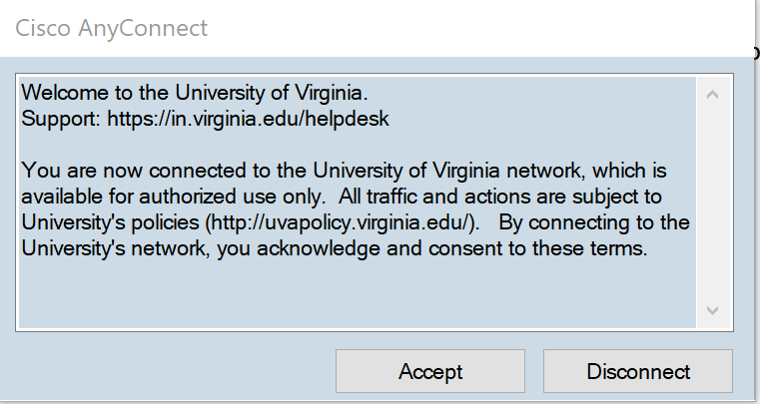
- If you have not completed the 'FERPA Training', complete the training in Workday: FERPA Training.
- Email the advisor for your program to confirm that you can log into the High Security VPN and that you have completed both trainings. Include a screen shot from Workday showing that you’ve completed the FERPA training.
- Once you receive confirmation from the advisor that your access to TDS has been granted, you will log in at https://educationabroad.virginia.edu.

